
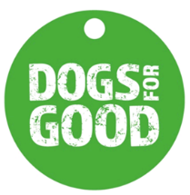
2024 Volunteer National Excellence Awards in partnership with The Marsh Charitable Trust

Nomination Form

Name of volunteer(s):
Volunteer(s) role/s:
Nominated by:
Contact email/tel of Nominator:
Please tick which award the volunteer(s) is being nominated for. If you are unsure which category to nominate in, please do not worry. Leave it blank as the selection panel will consider all nominations.

  - Fundraiser / Supporter Group Volunteer of the Year

  - Puppy Volunteer (Breed Stock Holders, Puppy Socialisers and Puppy Boarders) Of the Year

  - Speaker of the Year

  - Dog Volunteer (Temporary Boarders, Activity, Family, and Community Dog Holders, Drivers) of the year

  - Community Impact Volunteer of the Year

Please provide a summary statement outlining the volunteer(s) role and why you have nominated them (No more than 750 words). The award must be for volunteering carried out between September 2023 and August 2024. The panel is looking for as much detail and information as possible ie, why you believe the nominee has gone above and beyond, or been exceptional in their service.

Print Signature:

