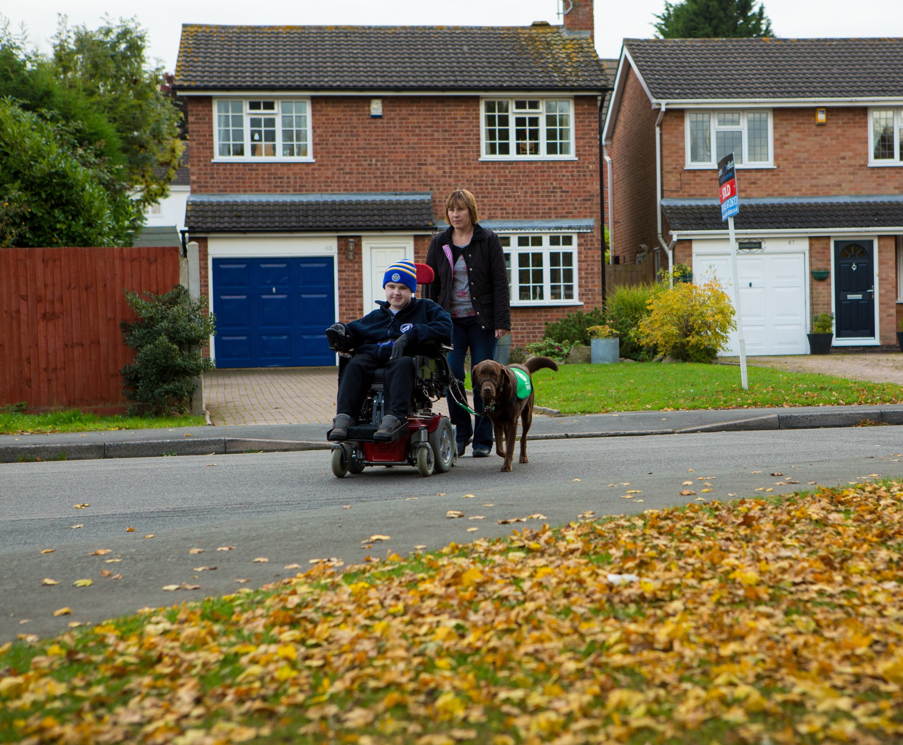


Application Form
Assistance Dogs for Children
contents

Applicant Information
your life with a dog
Property details
Garden details
Vehicle information
TL employment information
TL voluntary Work
TL university/college information
Your Child’s School/college details
health
weekly routine
free running
support network
dog experience
training course
other details
safeguarding
signatures & declaration

Please note that TL refers to Team Leader (responsible adult)

Please remember to refer to the Guidance Notes when completing this form. They will provide you with examples and the format needed to answer many of the questions. It is advisable to read through the Guidance Notes before completing the Application Form.

Should you run out of space to answer a question on the Application Form or need to provide us with extra information, please attach additional sheets to the back of this Application. Please note on these sheets the questions to which the additional information refers.

Please note that the completion of this form does not guarantee that your application will be approved. The purpose of this form is to enable Dogs for Good to make an initial assessment of your request to train with a dog provided by the Charity; and all applications are considered on a case-by-case basis. Following submission of application and supporting documentation, progression of all applications are subject to further exploration which may include an in-person home visit.

It is essential that you complete all questions, please.

Dogs for Good Application

Applicant Information
Team Leader’s Name(including title): |  |  |  |  |  |  |  |  |  |  |  |  |  |  |  | Date of Birth:
Preferred Pronoun:
He/him She/her They/them Other:
Child’s Name(including title): |  |  |  |  |  |  |  |  |  |  |  |  |  |  |  | Date of Birth:
Preferred Pronoun:
He/him She/her They/them Other:
Tel (Home): |  |  |  |  |  |  |  |  |  |  |  |  |  |  |  | Mobile:
Email address:
Preferred Contact Method:
Home Mobile Email
Current full residential address:

Household residents:
Please note, applications from households with very young children / babies will be considered on a case by case basis
Name |  |  |  |  |  | Age |  |  |  |  |  | Relationship to TL |  |  |  |  |  | Please list any health conditions they have
Pets in household:
Please note, if you have a pet dog, there must be one handler per dog for lead walks, i.e. you will not be able to walk your pet dog(s) and assistance dog on lead together by yourself. This may mean walking your assistance dog separately, or having someone else with you who can handle your pet dog(s).
If you have 2 or more pet dogs, you must have another adult in the household who can assist with the dogs, so that you can focus on your assistance dog.
If your pet dog is not neutered, please let us know as this may affect whether you are accepted for an assistance dog, and the dog you are subsequently matched to. This will be decided following an assessment of your pet dog, and is to prevent any possibilities of a working dog being impacted by distractions such as; hormone levels, seasons, phantom pregnancies, etc. Please note if your dog/bitch is neutered we may ask for evidence of this in the form of veterinary notes.
Name |  |  | Species/Breed |  |  |  |  |  |  | Age & Sex |  |  |  |  |  |  |  | Are they good with/used to dogs?
If you currently still have a Dogs for Good assistance dog, or any other pet dogs, how do you plan to ensure both dogs get adequate exercise and their health needs met? (Please be aware that the 2 dogs cannot be walked together, each dog must have their own handler)

Health
Child’s disability/diagnosis:
Is the condition: Stable ☐ Progressive ☐
Please detail any secondary conditions they have:
Please indicate if your child has any of the below and provide details:
 |  |  |  |  | Pain |  |  |  |  |  |  | Loss of power/strength |  |  |  |  |  |  |  | Loss of movement
Neck/Head
Back
Right arm/hand
Left arm/hand
Right leg/foot
Left leg/foot
Any further comments:
Do you (the TL) have any health conditions? Please detail:
Can you (the TL) maintain 3 hours of activity every day:

Yes ☐No ☐

If no, how much activity can you sustain each day:
Please detail any specialist care your child receives and how often:
Are other care professionals (social workers, occupational therapists, physiotherapists) aware of your child’s application:
Does your child have:
 |  |  |  |  |  |  |  |  |  | Yes |  |  |  |  |  |  |  | No
Hearing Impairment |  |  |  |  |  |  |  |  |  | ☐ |  |  |  |  |  |  |  | ☐
Visual Impairment |  |  |  |  |  |  |  |  |  | ☐ |  |  |  |  |  |  |  | ☐
Epilepsy |  |  |  |  |  |  |  |  |  | ☐ |  |  |  |  |  |  |  | ☐
Seizures |  |  |  |  |  |  |  |  |  | ☐ |  |  |  |  |  |  |  | ☐
Diabetes |  |  |  |  |  |  |  |  |  | ☐ |  |  |  |  |  |  |  | ☐
Blackouts/Loss of Consciousness |  |  |  |  |  |  |  |  |  | ☐ |  |  |  |  |  |  |  | ☐
Do you (the TL) have:
 |  |  |  |  |  |  |  |  |  | Yes |  |  |  |  |  |  |  | No
Hearing Impairment |  |  |  |  |  |  |  |  |  | ☐ |  |  |  |  |  |  |  | ☐
Visual Impairment |  |  |  |  |  |  |  |  |  | ☐ |  |  |  |  |  |  |  | ☐
Epilepsy |  |  |  |  |  |  |  |  |  | ☐ |  |  |  |  |  |  |  | ☐
Seizures |  |  |  |  |  |  |  |  |  | ☐ |  |  |  |  |  |  |  | ☐
Diabetes |  |  |  |  |  |  |  |  |  | ☐ |  |  |  |  |  |  |  | ☐
Blackouts/Loss of Consciousness |  |  |  |  |  |  |  |  |  | ☐ |  |  |  |  |  |  |  | ☐
Is your child receiving any prescribed medication:
Yes ☐ No ☐
If yes, please detail and note how this impacts on your child:
Are you (the TL) receiving any prescribed medication that could affect your ability to train with a dog:
Yes ☐ No ☐
If yes, please detail:
Please indicate any other health and wellbeing factors affecting you or your child:
Factor |  |  |  |  |  |  | Who does it affect TL or Child? |  |  |  |  |  | How it affects you/them
Anxiety/Depression/Stress
Attention Deficit Disorder
Dementia/Alzheimer’s Disease
Developmental Delay
Dyslexia
Learning Disability
Mental Health Conditions Other Than Mood Disorders, e.g. Schizophrenia
Non or Limited Speech
Long Term Memory Impairment
Short Term Memory Impairment
Other – please detail:
Please indicate any additional sensitivities affecting your abilities:
 |  |  |  | Who does it affect TL or Child? |  |  |  |  | How it affects you/them
Allergies
Asthma
Cold
Environment
Heat
Sensory
Other:
What mobility aid(s) does your child use:
Mobility Aid | Inside the home | Outside the home
Walking sticks / Crutches
Walker
Prothesis
Stroller
Manual W Chair
Power W / Chair
Scooter
None
Other – Please detail

Please tell us if your child uses these all of the time or for specific routines/activities:
If your child walks, or self-propels, please provide information on how long your child can sustain this for at any one time:

Can your child hold a lead: Yes ☐ No ☐

Your life with a dog
How do you imagine your life would change if you had an assistance dog?
How do you imagine your child’s life would change if you had an assistance dog?
What activities would you & your child like to do-that maybe you don’t do now-with an assistance dog?
How could an assistance dog help you and your child inside and outside your home?
Where would you like to go with an assistance dog?
What prompted you to apply for an assistance dog?

Property Details
Property:
Owned☐ Rented☐ Living With Parents ☐ Shared Housing ☐

If your property is rented, you must provide written permission from your landlord/housing association to have an assistance dog at the property. This should include permission to have a dog in your home, as well as confirmation that the dog can use the garden for toileting off lead. It may be necessary for the garden to be made secure and accessible for you and a dog (e.g adding a gate), so permission should be obtained for this if appropriate. This is particularly important if your garden is communal.
If you move house in the future, it will be your responsibility to check the permissions and requirements of your new landlord, ensuring they are still suitable for you and an assistance dog.

Type of property:

House☐

Flat – Ground☐

Flat – Upper☐

Bungalow☐

Sheltered Housing☐

Other (please detail any other information):

Please detail if you have any future plans to move home (Planned timescale, where to?):
Is there any building work occurring at the property / do you have any future plans for work to take place- please provide details (type of work, completion date):
Please provide details of where the safe space will be located in the house, please also provide pictures to accompany your application:

Garden Details
Is the garden directly accessible from the house:

Yes ☐ No ☐

If no, state how you access the garden:

Is the garden communal:
Yes ☐ No ☐

If yes, do you have access to a safe and secure area for the dog to use for toileting within the communal garden

Yes ☐ No ☐

If yes, please enclose written permission from your landlord that you are able to use the communal garden for a dog to toilet in and, if necessary, that they give you permission to install a toileting pen.
Is the garden fully secure? (by fencing that is at least 5ft in height all the way around the garden) Please provide pictures of your garden to accompany your application:

Yes ☐ No ☐

If not, please detail why it is not secure and indicate if you are prepared to make changes to secure it:
What is the height of the lowest part of any fencing in your garden (provide measurement):

Where and on what surface will the dog toilet:

If needed, are you prepared to install a toileting a pen:

Yes ☐ No ☐
If no, please detail reasons as to why:

Vehicle Information
If you have one, how does your child access your vehicle:
How will the dog travel in the vehicle (please see guidance notes for information on safety guidelines and law):
Please detail any transport that you currently use or might wish to use in the future:
Type |  |  |  |  |  |  |  |  |  | Frequency |  |  |  |  |  |  |  | Duration
Car
Taxi
Bus
Train
Tram
Ferry
Plane
Will you be seeking special permission to take your dog abroad with you? If so, please detail where, type of transport used and how often you take this trip.
Please note permission must be sought from the charity to travel with an assistance dog abroad, and each request is considered individually with the health and welfare of the dog paramount in our consideration:

TL Employment Information
Current employer:
Full Mailing Address:
Phone: |  |  |  |  |  |  | E-mail:
Hours of work:
 |  | Mon |  |  | Tues |  |  | Wed |  |  |  | Thur |  |  |  |  | Fri |  |  | Sat | Sun
Start Time
AM Break
Lunch Break
PM Break
Finish Time
Do you want to take your dog with you: (If no, skip to next section)
Yes ☐ No ☐
Do you have permission from your employer to take a dog to work with you:
Yes ☐ No ☐
Does your employer have any concerns about a dog attending with you:
Yes ☐ No ☐
If yes, what are the concerns:
Where and on what surface will the dog toilet whilst you are at work:
Where will the dog be located during the day:
Are your employers aware of and supportive of the time required of you to complete early training with an assistance dog and with your child? (This would require you have at least the first full week off following a dog being placed, with a gradual and phased introduction to the workplace for your dog, ensuring settled and appropriate behaviour in the workplace.)
Yes ☐ No ☐

TL Voluntary Work
Organisation:
Full Mailing Address:
Phone: |  |  |  |  |  |  | E-mail:
Hours of work:
 |  | Mon |  |  | Tues |  |  | Wed |  |  |  | Thur |  |  |  |  | Fri |  |  | Sat | Sun
Start Time
AM Break
Lunch Break
PM Break
Finish Time
Do you want to take your dog with you: (If no, skip to next section)
Yes ☐ No ☐
Do you have permission from your voluntary work to take a dog to work with you:
Yes ☐ No ☐
Does your voluntary work have any concerns about a dog attending with you:
Yes ☐ No ☐
If yes, what are the concerns:
Where and on what surface will the dog toilet:
Where will the dog be located during the day:
Is your workplace aware of and supportive of the time required of you to complete early training with an assistance dog and with your child? (This would require you have at least the first full week off following a dog being placed, with a gradual and phased introduction to the workplace for your dog, ensuring settled and appropriate behaviour in the workplace.) Can you meet the notice period and commitment to training times:
Yes ☐ No ☐

TL university/college
University/College:
Mailing Address:
Phone: |  |  |  |  |  |  | E-mail:
Course Start & End Date:
Hours of study:
 |  | Mon |  |  | Tues |  |  | Wed |  |  |  | Thur |  |  |  |  | Fri |  |  | Sat | Sun
Start Time
AM Break
Lunch Break
PM Break
Finish Time
Do you want to take your dog with you: (If no, skip to next section)
Yes ☐ No ☐
Do you have permission from your University/College to take a dog on site with you:
Yes ☐ No ☐
Does your University/College have any concerns about a dog attending with you:
Yes ☐ No ☐
If yes, what are the concerns:
Where and on what surface will the dog toilet:
Where will the dog be located during the day:
Is you University/College aware of and supportive of the time required of you to complete early training with an assistance dog and with your child? (This would require you have at least the first full week off following a dog being placed, with a gradual and phased introduction to the workplace for your dog, ensuring settled and appropriate behaviour in the workplace.) Can you meet the notice period and commitment to training times:
Yes ☐ No ☐

YOUR Child’s School/college details
School/College:
Full Mailing Address:
Phone: |  |  |  |  |  |  | E-mail:
Type of School: Main Stream ☐ ABA ☐ Autism Based ☐ SEN ☐
School Hours:
 |  | Mon |  |  | Tues |  |  | Wed |  |  |  | Thur |  |  |  |  | Fri |  |  | Sat | Sun
Start Time
Finish Time
Do you have permission to take your child out of school for training and aftercare visits:
Yes ☐ No ☐
Do you have permission to take a dog onto school grounds: (If needed)
Yes ☐ No ☐ Not needed ☐

Weekly Routine
Please complete the following tables to outline your weekly routine:
MON | TL |  |  |  |  |  |  |  |  |  |  |  |  | Child
06.00
07.00
08.00
09.00
10.00
11.00
12.00
13.00
14.00
15.00
16.00
17.00
18.00
19.00
20.00
21.00
22.00
23.00
Environments encountered during this day:

TUES | TL |  |  |  |  |  |  |  |  |  |  |  |  | Child
06.00
07.00
08.00
09.00
10.00
11.00
12.00
13.00
14.00
15.00
16.00
17.00
18.00
19.00
20.00
21.00
22.00
23.00
Environments encountered during this day:

WED | TL |  |  |  |  |  |  |  |  |  |  |  |  |  | Child
06.00
07.00
08.00
09.00
10.00
11.00
12.00
13.00
14.00
15.00
16.00
17.00
18.00
19.00
20.00
21.00
22.00
23.00
Environments encountered during this day:

THUR | TL |  |  |  |  |  |  |  |  |  |  |  |  | Child
06.00
07.00
08.00
09.00
10.00
11.00
12.00
13.00
14.00
15.00
16.00
17.00
18.00
19.00
20.00
21.00
22.00
23.00
Environments encountered during this day:

FRI | TL |  |  |  |  |  |  |  |  |  |  |  |  | Child
06.00
07.00
08.00
09.00
10.00
11.00
12.00
13.00
14.00
15.00
16.00
17.00
18.00
19.00
20.00
21.00
22.00
23.00
Environments encountered during this day:

SAT | TL |  |  |  |  |  |  |  |  |  |  |  |  | Child
06.00
07.00
08.00
09.00
10.00
11.00
12.00
13.00
14.00
15.00
16.00
17.00
18.00
19.00
20.00
21.00
22.00
23.00
Environments encountered during this day:

SUN | TL |  |  |  |  |  |  |  |  |  |  |  |  | Child
06.00
07.00
08.00
09.00
10.00
11.00
12.00
13.00
14.00
15.00
16.00
17.00
18.00
19.00
20.00
21.00
22.00
23.00
Environments encountered during this day:

Please detail any other regular events/appointments/commitments you attend:

Free RuNning
Please tick the areas that you intend to free run your dog and note if these are within walking distance or require transportation to access them. (The Guidance Notes provide information that can help you decide on a sufficiently secure free run area)

 | Within walking distance | Travel there by car | Other
Town Park
Country Park
Rural
Wooded Areas
Beach
Near Water

Please also provide photos of two free run environments to accompany your application.
Are you prepared to ensure that the dog is exercised every day regardless of the weather:

Yes ☐ No ☐

Please detail how you will ensure the dog is exercised each day:
Have you checked that you are familiar with the route to the free run area and that you are able to access it throughout the year/in all weathers:

Support Network
Please list at least two people that will be able to look after a dog at short notice. You will need to ensure that their house and garden are secure for a dog and that they are able to look after the dog as instructed and potentially in an emergency situation. It is preferred that at least one of your network does not share the same address as you, and that support networks do not live more than 2 hours away from your home. Confirmation in writing will be needed from them:
Name |  |  |  | Residential Address |  |  |  |  |  |  |  |  |  |  |  |  |  |  | Phone

Dog Experience
Have you owned a dog before:
Yes ☐ No ☐
Tell us about any previous experience of exposure to dogs:
If any, what experiences or exposure has your child had around dogs;
Is your child able and happy to give treats to a dog by hand:
Are you happy to accept any dog that the Charity identifies as being suitable regardless of breed, sex, colour:
Yes ☐ No ☐
If no, please detail:

Training Course
Are you able to attend a half day Dog Handling Session at one of our centre’s following an assessment decision? (This is unlikely to require your child to be in attendance)

Are you able to attend a (minimum) 5 day training course once a dog has been matched and confirmed for you

From Home? (Your child would not be required to attend this stage of the training process)
Yes ☐ No ☐

From one of our centre’s or a hotel?

Yes ☐ No ☐
If no, please explain why:

What special arrangements will you need for a stay away (if needed):
Please provide details of your emergency contact (this needs to be someone who would not attend the training course with you):
Name:
Residential Address:
Town: |  |  |  |  |  |  | County: |  |  |  |  |  |  |  |  |  |  |  | Postcode:
Phone: |  |  |  |  |  |  | E-mail: |  |  |  |  |  |  |  |  |  |  |  | Fax:
Relationship to you:

other details
Please affix a recent passport style photograph of yourself (Team Leader) here |  |  |  |  |  |  |  |  |  |  | Please affix a recent passport style photograph of your child here
Please list any holiday or appointment dates that you know of, in the next year or two when you would be unavailable for training:
Have you applied for, had or been declined an Assistance Dog from another charity:
Yes ☐ No ☐
If yes, please detail:
Is there anything else that you would like to tell us/make us aware:

safeguarding
Do you have any unspent criminal convictions, police cautions, reprimands or warnings or do you have any criminal cases pending against you:
Yes ☐ No ☐
If yes, please provide details:

Signatures
By signing below, I understand and confirm that:

- To the best of my knowledge, all the information submitted on this form is true, accurate and complete at the time of writing.

- I have read and agree to the Charity’s Privacy Policy. This enables the Charity to perform its responsibilities, respond to your request, and decide if we can help you in the way you need. The Charity will collect and process certain personal data relating to you in accordance with the attached Privacy Policy. This Policy may be updated from time to time in which case you will be notified of changes.

- Dogs for Good shares a commitment to safeguarding and promoting the welfare of children, young people and vulnerable adults. The Charity’s commitment is underpinned by robust processes and procedures that seek to maximise opportunity, minimise risk and continuously promote a culture that embraces the ethos of safeguarding amongst its workforce.

Signature of applicant: |  |  |  |  |  |  |  |  |  |  |  |  |  |  |  |  |  |  | Date:

Please refer to the information below to ensure that you have provided relevant supporting information in relation to your assistance dog application.

Landlord Permission:  If you do not own your property, please provide written confirmation from your Landlord/Housing association etc. that you have permission to keep an assistance dog at the property and to use the garden for the purposes of their toileting. | ​​☐​
Employment/Study/Volunteer Permission:  If you wish to take an assistance dog to your place of work, study or volunteer, please provide written confirmation from your employer/place of education etc. that you have permission for the dog to accompany you. | ​​☐​
School Permission:  If your child currently attends school, please provide written confirmation from them that you have permission for your child to take time out of school to attend training and aftercare visits relating to an assistance dog.  Additionally, if you wish to take an assistance dog onto the school property for drop off/collection times or meetings etc. please provide written confirmation from them that an assistance dog can enter the school grounds. | ​​☐  ​  ​  ​  ​​☐​​
Support Network Confirmations:  Please provide written confirmation from your nominated support network. For your convenience we have included a document overleaf that you can share with them to help clarify the level of support they are able to offer. | ​​☐​
Application Photographs:  To demonstrate your suggested free run areas, garden etc.  Please provide general photographs of the key rooms of your home which a dog would have access to. | ​​  ☐​  ​​☐​

