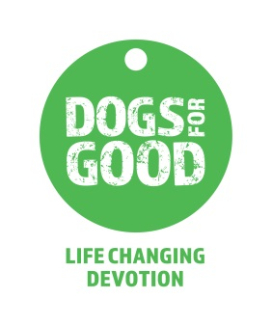
Equal Opportunities Monitoring Form

Dogs for Good is committed to equality of opportunity in all its employment practices, policies and procedures. To assist in the implementation and monitoring of this policy, we would be grateful if you could provide us with the information requested below.

The information obtained via this form is used for equal opportunities monitoring only and is not made available to those involved in the shortlisting process. Any information given will be used only to support the diversity and equal opportunities policy and in accordance with the principles of the Data Protection Act 2018.

Post applied for: Click here to enter text.
Location of post: Click here to enter text.
How did you hear about this vacancy?: Click here to enter text.

Do you currently work for Dogs for Good?
Yes, on a fixed term contract: ☐ Yes, on a permanent contract: ☐ No: ☐

Details of the post you are applying for
Fixed Term Contract: ☐ Permanent Contract: ☐

Full Time (35 hrs + per week): ☐ Part Time (less than 35 hrs per week): ☐

Please identify the age band which applies to you
16 – 24: ☐ 25 – 34: ☐ 35 – 44: ☐ 45 – 54: ☐ 55+: ☐
Choose not to disclose: ☐

Gender
Male: ☐ Female: ☐ Choose not to disclose: ☐

To which ethnic background do you belong?
Asian – Indian: ☐ Asian – Pakistani: ☐ Asian Bangladeshi: ☐
Black – British: ☐ Black – Caribbean: ☐ Black – African: ☐
Black – Other: ☐ Chinese: ☐ Mixed – White & Black Caribbean: ☐
Mixed – White & Asian: ☐ Mixed – Other: ☐ Mixed – White & Black
African: ☐
Other Ethnic Group: ☐ White – British: ☐ White – Irish: ☐
White – Other: ☐ Choose not to disclose: ☐

Disability
A person has a disability under the Disability Discrimination Act (1995) if he or she has a physical or mental impairment, which has a substantial and long term adverse effect on his or her ability to carry out normal day to day activities. Long term means has lasted, or is expected to last, for 12 months.

Do you consider yourself to have a disability?
Yes: ☐ No: ☐ Choose not to disclose: ☐
Do you consider yourself to be blind or partially sighted?
Yes: ☐ No: ☐

The information on this form will be processed by the Charity purely for the purposes of equal opportunities monitoring and will be used in the compilation of statistical information, the purpose of which is to ensure that the Association maintains compliance with its equal opportunities policy. I consent to the data contained on this for being processed for this reason in accordance with data protection legislation for the time being in force.

Thank you, your co-operation is much appreciated. Please return this form with your completed application.

